**A case study on pollution in 3 major rivers in India: Ganges, Yamuna, Sabarmati**

Bachelor of Technology

By - Group 17



ESC205A- Environmental Sciences

Indraprastha Institute of Information Technology, Delhi, New Delhi, India - 110020

November 2019

# Acknowledgement

We would like to show our instructor Dr. Jitin Rahul immense gratitude for sharing his pearls of wisdom in the field of Environmental Science with us.

We are grateful to our Teaching Assistants Ritam Biswas, Shraddha Gupta, Abhishek Singh Chauhan, Abhishek Vyas, Chirag Chawla, Nikunj Agarwal, P Akshay Kumar, Deekshant Mamodia, Lucky Agarwal, Sumedha Bhatia and Govind Soni for keeping us updated with various kinds of environment-related articles.

Nobody has been more important to us in the pursuit of this project than the members of our family. We thank our parents, whose love and guidance will always be with us in whatever we pursue. They are the ultimate role models for us.

Abstract

The idea of this research is to study the three most polluted rivers in India - Yamuna, Ganges, and Sabarmati. These rivers have a rich history and heritage. These have had the utmost importance in Hindu mythology. People have worshipped these rivers. These rivers flow through various parts of the country and are a source to which all kinds of life are dependent. Despite this, many factors have lead to the contamination of these rivers. The major factors include - industrialization, urbanization, organic waste, death rituals, religious beliefs, and agriculture. The impact of water pollution on human life is lethal. Some cases have also lead to death. The element that is responsible for keeping us alive is even killing us. We further explore how we can reduce pollution in these rivers. We also look at methods adopted by other countries to reduce pollution in their rivers. Based on this, we feel that there is an urgent need to evaluate the condition of rivers and take appropriate actions to preserve them.

# Table of Contents

1. Introduction **6**
2. History **8**
   1. History of the Ganges River **8**
   2. History of the Yamuna River **8**
   3. History of the Sabarmati river **9**
3. Geography **10**
   1. Geography of Ganga River **10**
   2. Geography of Yamuna River **11**
   3. Geography of Sabarmati river **13**
4. Causes of Pollution **13**
   1. Industrial waste **14**
   2. Organic waste in the Ganges **15**
   3. Death rituals performed in the Ganges **16**
   4. Urbanization **17**
   5. Agriculture practices in Yamuna **19**
   6. Religious beliefs **20**
   7. Sabarmati Pollution **21**
5. Effects of water Pollution **22**
6. Methods to Reduce Pollution **26**
   1. Thames River **26**
   2. Pollution control in China **27**
   3. Steps that can be taken to reduce pollution **29**
   4. Ganga Action Plan (GAP) **30**
7. Result **31**
8. Discussion **32**

References **34**

List of Tables

|  |  |
| --- | --- |
| **Table number** | **Description** |
| Table 1 | Ranking of polluted rivers |
| Table 2 | Contributions of different Industries in pollution |
| Table 3 | Water Quality of different Indian rivers |
| Table 4 | Toxicity of Pesticides |
| Table 5 | Comparison between GAP and different plans |
| Table 6 | Pollution comparison of 2015 and 2019 |

Abbreviations

CPCB - Central Pollution Control Board

MlD - Million litres per day

WHO - World Health Organization

GPCB - Gujarat Pollution Control Board

PSS - Paryavaran Suraksha Samiti

List of Figures

|  |  |
| --- | --- |
| **Figure Number** | **Description** |
| Figure 1 | More than 100 Million people live in areas of poor water quality. |
| Figure 2 | Traversal of Ganga |
| Figure 3 | Traversal of Yamuna |
| Figure 4 | Traversal of Sabarmati |
| Figure 5 | Flow of sewage directly into river |
| Figure 6 | Contamination of stream |
| Figure 7 | Water treatment by class 1 urban communities |
| Figure 8 | City wise contribution of pollution to Yamuna |
| Figure 9 | Industrial waste in Sabarmati River |
| Figure 10 | Comparison between A-composition and B-Composition pesticides in India. |
| Figure 11 | Health effects of Pollution |
| Figure 12 | Transformation of Thames river |
| Figure 13 | Driving force vs Action |
| Figure 14 | Help us green( we make sure devotion doesn't turn into pollution) |
| Figure 15 | Omnipresent Robot Tech Pvt Ltd |

# 

# **1. INTRODUCTION**

India is a country with 400 rivers and their tributaries. The main among them are Brahmaputra, Ganges, Godavari, Krishna, Kaveri, Mahanadi, Narmada, Tapi, Yamuna, and Sabarmati. With so many rivers and that too covering the whole Indian subcontinent, these rivers become one of the essential natural resources for our country. Rivers make the soil near them fertile, which leads to a better plantation and more food, they give us water, they provide a living environment to aquatic animals, etc. These rivers also offer great tourist spots and even spots for sports activities like swimming, water rafting, kayaking, etc. Thus keeping them clean is an essential requirement, and we as Indians should take responsibility for keeping them clean. Unfortunately, most of these rivers are incredibly polluted. According to India’s Central Pollution Control Board (CPCB), [63](https://timesofindia.indiatimes.com/city/agra/63-of-sewage-flows-into-rivers-untreated-every-day-Central-Pollution-Control-Board/articleshow/54531095.cms)% of the urban sewage flowing into rivers (some 62 billion litres a day) is untreated. With an increase in the pollution of these rivers, the pollution in the respective tributaries also increases and thus results in even more pollution. The aquatic life that lives in these rivers face the danger of death and may also lead to extinction. According to a source, Ganges and Yamuna are among the top 10 most polluted rivers in the world. The people living in the areas that are near these rivers also face the danger of water-borne diseases. There was a study that linked the increasing cases of diseases like typhoid, diarrhoea, and hepatitis in Delhi to the pollution in the Yamuna river, which is a significant source of water for the city, and also many vegetables are grown using the water of this river.

The biggest reasons for pollution in the rivers would include: factories dumping waste into the rivers, city waste or common waste being dumped into the rivers, dumping of sewage into the rivers, and many more. Most of these causes can be fixed, and significant magnitudes could decrease the pollution in the rivers. New laws, more awareness, banning factories from dumping waste into the rivers, putting a fine on humans for throwing the trash into the river, etc. can all lead to much more cleaner rivers. Also, in these modern times, there are amazing machines capable of cleaning the river water. These machines and similar advancements in technology can also be used to address this problem of pollution, and we can boast cleaner rivers.

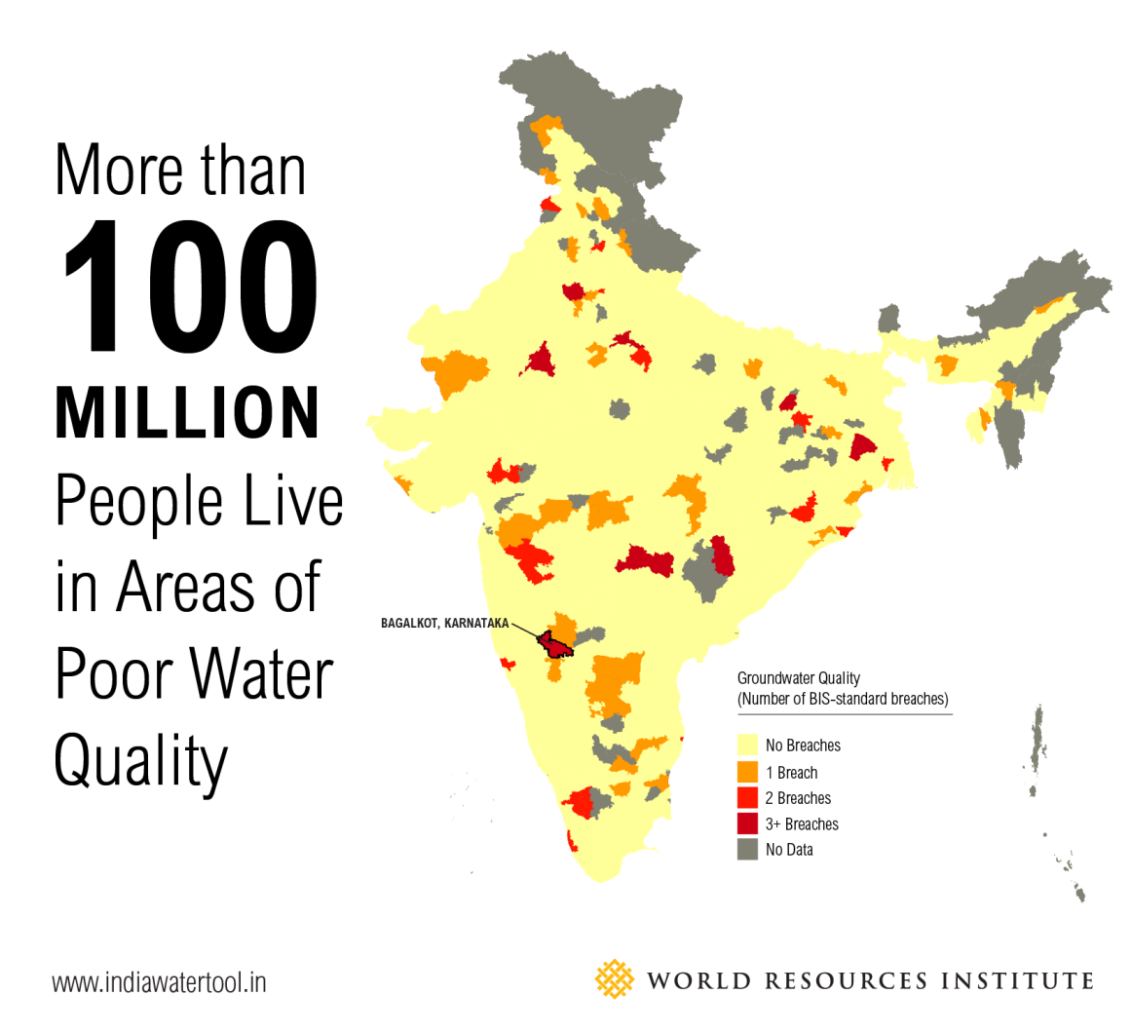[[Source]](https://www.kent.co.in/blog/wp-content/uploads/2017/02/Poor-quality-water.png)

(Figure 1)

About 63% of the surface water of India is unfit for consumption. That is a very high percentage. It shows that this problem of water pollution is not a small one. It can be fixed, or at least its severity can be decreased if some precautions are taken. Although taking these precautions might be hard, but these need to be taken, or else the condition of India as a country would be profoundly affected.

**2. HISTORY**

**2.1 History of the Ganges River**

The Ganges River, popularly known as “Ganga” is a river of the plains of the northern Indian subcontinent. Throughout history, it has been a holy river to the Hindus. The river has been personified as the goddess Ganga in ancient art and texts. In Hindu mythology, Vishnu created the Ganges river, in his incarnation as the dwarf brahmin, took two steps to cross the universe. In the Mahabharata, Ganga marries King Shantanu. Together they had a son named Bhishma, who sided with the Kauravas in the famous battle. Ganga and Shantanu relationship comes to a shattering end when the goddess is discovered to have drowned her children.

The Ganges is considered a tirtha, which means a crossing point between heaven and earth. At a tirtha, prayers and offerings are thought most likely to reach the gods, and, in the other direction, blessings can descend most readily from heaven.

It was the cradle of successive civilizations from the Mauryan empire of Ashoka in the 3rd century B.C. to the Mughal Empire in the 16th century.

**2.2 History of the Yamuna River**

The name Yamuna (also called the Jumna or Jamna) is by all accounts got from the Sanskrit word "Yama," signifying 'twin,' and it might have been applied to the stream since it runs parallel to the Ganges. The Yamuna is referenced at numerous spots in the Rig Veda, Atharvaveda, Aitareya Brahmana and the Satapatha Brahmana. In the Rigveda, the narrative of the Yamuna depicts her "unnecessary love" for her twin, Yama, who thus requests that she locate a reasonable counterpart for herself, which she does in Krishna.

The story is additionally pointed by point in the sixteenth century Sanskrit psalm, Yamunashtakam, a tribute by the savant Vallabhacharya. Here the narrative of her plummets to meet Krishna and to cleanse the world has been placed into the refrain. The song likewise adulates her for being the wellspring of every single, profound capacity. And keeping in mind that the Ganges is viewed as an embodiment of parsimony and higher information and can allow Moksha or freedom, it is the Yamuna, who, being a holder of unbounded love and sympathy, can concede opportunity, even from death, the domain of her senior sibling.

In the Mahabharata, the Pandava capital of Indraprastha was arranged on the banks of Yamuna, viewed as the site of present-day Delhi.

The more significant part of the incredible realms which administered over a more substantial piece of India was situated in the exceptionally prolific Ganges–Yamuna bowl, including the Magadha, Maurya Empire, Shunga Empire, Kushan Empire, and the Gupta Empire. And many had their capitals here, in urban areas like Pataliputra or Mathura. These streams were venerated all through these realms that thrived on their banks; since the time of Chandragupta II, statues both the Ganges and Yamuna became normal all through the Gupta Empire. Further toward the South, pictures of the Ganges and Yamuna are found amid sanctums of the Chalukyas, Rashtrakutas, and on their imperial seals, preceding them, the Chola Empire likewise included the river into their design themes. The Three River Goddess place of worship, by Kailash, shake cut Temple at Ellora, shows the Ganges flanked by the Yamuna and Saraswati.

**2.3 History of the Sabarmati river**

The Sabarmati river is also known as Shvabhramati. One of the oldest myths regarding the origins of the Sabarmati river is that Lord Shiva once brought the goddess Ganga to Gujarat, and that lead to the birth of the Sabarmati river. A shloka from a manuscript of Shv Baramati Mahatmya of Padampura calls the river Kashyapi Ganga.

Like many other cities, Ahmedabad also developed as a city on the banks of the Sabarmati watercourse. Social, religious, and politicals beliefs and activities flourished on the banks of Sabarmati river, during India’s independence struggle, Mahatma Gandhi established Sabarmati Ashram as his home on the banks of this river. Ellis bridge was the first bridge to be built on the Sabarmati river which was which divided the city into two parts.

The National Water Quality Program conducted by Central Pollution Control Board (CPCB) positions the Sabarmati River in third place among the most polluted rivers in India.

## **3. GEOGRAPHY**

**3.1 Geography of the Ganges river**

The Ganges river rises from the southern Great Himalayas. Its five headstreams — Bhagirathi, Alaknanda, Mandakini, Dhauliganga, and Pindar — all rise in the mountainous regions of Uttarakhand. The source of the Ganges is Gaumukh, which is about 21 km southeast of Gangotri. The Alaknanda and Bhagirathi rivers unite at Devprayag to form the mainstream known as the Ganges. The glacier is at an elevation of 3,892 m. The Ganges River goes farther downstream, where the Alaknanda and Bhagirathi rivers join. The Ganges creates a narrow, rugged canyon as it flows out of the Himalayas as it flows.

The Ganges River streams towards the outskirts of Bangladesh. It is the most extended stream in India and streams for around 2,525 km from the Himalayan Mountains to the Bay of Bengal. The flow has the second most prominent water release on the planet, and its bowl is the most intensely populated on earth, with more than 400 million individuals living in the bowl. When the Ganges River streams out of India and into Bangladesh, its principal branch is known as the Padma River. The Padma River is joined downstream by massive streams like the Jamuna and Meghna rivers. In the wake of joining the Meghna, it takes on that name before streaming into the Bay of Bengal. Before entering the Bay of Bengal, be that as it may, the river makes the world's most significant delta, Ganges Delta. This district is a profoundly fruitful dregs loaded region that spreads 59,000 sq km.

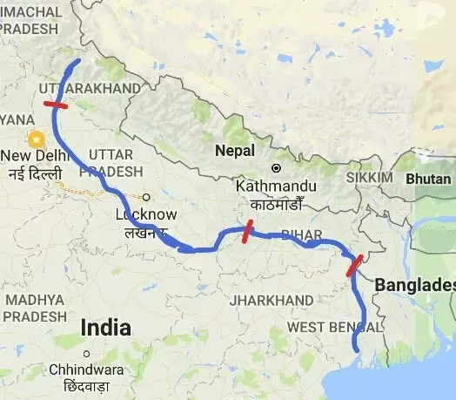

(Figure 2)

The Ganges has confused hydrology, and there are a few unique portrayals of its overall length and the size of its seepage bowl dependent on what tributary streams are incorporated. The most generally acknowledged length of the Ganges River is 1,569 miles 2,525 km, and its seepage bowl is assessed to be around 416,990 square miles 1,080,000 sq km.

**3.2 Geography of the Yamuna river**

The Yamuna is the second biggest tributary rivers of the Ganges and the longest tributary in India. Starting from the Yamunotri Glacier at a statue of 6,387 meters on the southwestern slants of Banderpooch pinnacles of the Lower Himalaya in Uttarakhand, it voyages a total length of 1,376 kilometers and has a seepage arrangement of 366,223 square kilometres, 40.2% of the whole Ganges Basin. It converges with the Ganges at Prayagraj.

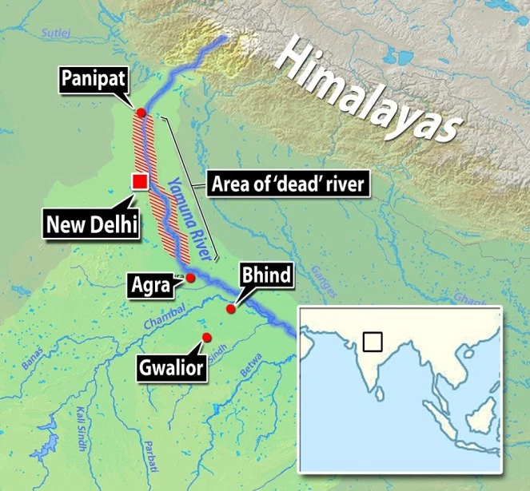

(Figure 3)

It crosses a few states: Haryana and Uttar Pradesh, passing by Uttarakhand and later Delhi, and meeting its tributaries in transit, including Tons, Chambal, its most extended branch which has its very own colossal bowl, trailed by Sindh, the Betwa, and Ken. From Uttarakhand, the river streams into the territory of Himachal Pradesh. It makes the profoundly rich alluvial Yamuna-Ganges Doab area among itself and the Ganges in the Indo-Gangetic plain. Almost 5.7 crore individuals rely upon the Yamuna's waters. With a yearly progression of around 10,000 cubic billion meters and utilization of 4,400 cubic meters, the river represents more than 70 percent of Delhi's water supply.

At the Hathnikund barrage, its waters are occupied into two massive channels: the Western Yamuna Canal streaming towards Haryana and the Eastern Yamuna Canal towards Uttar Pradesh. Past that point, the Yamuna is joined distinctly by the Somb, a regular stream from Haryana, and by the profoundly dirtied Hindon River close Noida, so it proceeds with just as a streaming sewage-bearing channel before joining the Chambal at Pachnada in Etawah District of Uttar Pradesh. The water of Yamuna is of "sensibly great quality" through its length from Yamunotri in the Himalayas to Wazirabad flood in Delhi, around 375 kilometres; beneath this, the release of wastewater through depletes between Wazirabad and Okhla. It renders the river to be severely contaminated.

**3.3 Geography of the Sabarmati river**

The Sabarmati river is the major west-flowing rivers of India. The river originates from the Dhebar lake in the Aravalli Range of Udaipur District, Rajasthan, at an elevation of about 750 meters above the sea level and submerge/meets in the Gulf of Khambhat in the Arabian Sea. The river stretches of about 371 km from Rajasthan to the state of Gujarat.

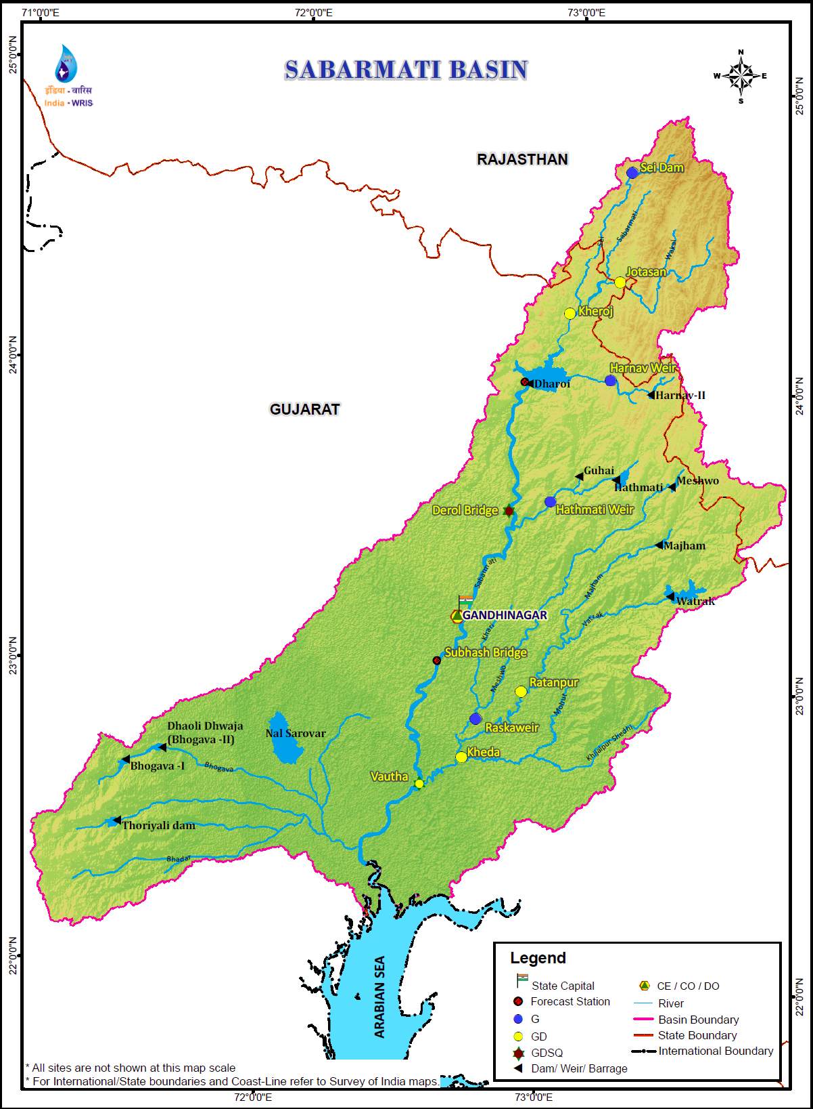

(Figure 4)

Sabarmati river covers only 48 km length in Rajasthan, while it covers 323 km in Gujarat. The Sabarmati river is dominated by the monsoon season. The season affects the river's flow. The Tributaries of the River Sabarmati are Harnav, Khari, Hathmati, Watrak, Sei, Dhami, etc. The Sabarmati rivers run through the two major cities of Gujarat Gandhinagar and Ahmedabad.

# **4. CAUSES OF POLLUTION**

|  |  |
| --- | --- |
| ***The top most polluted rivers in India(according to*** [***https://www.kent.co.in/blog/the-most-polluted-rivers-of-india/***](https://www.kent.co.in/blog/the-most-polluted-rivers-of-india/)***)*** | |
| **Rank** | **River** |
| **1** | **Yamuna** |
| **2** | **Ganga** |
| **3** | **Sabarmati** |
| 4 | Oshiwara |
| 5 | Damodar |

(Table 1)

**4.1 Industrial waste**

Compound waste has demonstrated to be a significant component of contamination. 20% of all pollution entering the stream is of this sort and originates from such sources as paper factories, sugar plants, and tanneries. Synthetic concoctions, for example, arsenic, cadmium, mercury, sulfuric acid. Compound colours and substantial metals habitually discover their way into the water of the stream and pose a massive risk. Hydrochloric corrosive and (CH3)2CO are dumped into the stream by pharmaceutical organizations. These synthetic mixtures are risky to nature, just as to the individuals who drink the water or wash in it. Along these lines, there have been ongoing pushes to have the earth cleaned and keep organizations from dumping unlawfully.

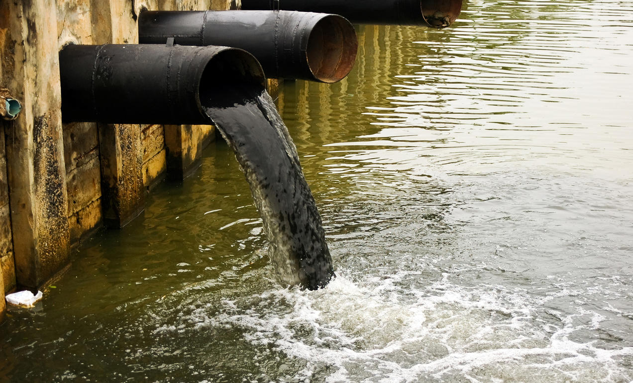[1]

(Figure 5)

Furthermore, 6,000,000 tons of synthetic compost and 9,000 tons of pesticides enter the water through spillover. Numerous individuals in the zone of the rivers are ranchers, and in this way, this is unavoidable without an appropriate framework. This manure is inconvenient to the earth, as it advances green growth development. This makes the fish be denied oxygen, which kills them. The pesticides are additionally harming life in the river and are unsafe to the individuals who drink the water too.

|  |  |
| --- | --- |
| Organic Chemistry | 100 |
| Distilleries | 103 |
| Fertilizer Plants | 154.6 |
| Sugar Industries | 410 |
| Steel Industries | 1087 |
| Textiles | 1746 |
| Pulp and Paper | 1906 |
| Engineering | 4250 |
| Others | 458 |

(Table 2)

**4.2 Organic waste in the Ganges**

Another pressing issue for the Ganges river is natural contamination or sewage. 2,900,000,000 litres of wastewater is siphoned into the Ganges river day by day. Just 31% of this sewage ever gets any treatment. That implies that the other 69% of the sewage dumped into it is crude sewage, much the same as what you flush down the latrine. A marker of human or animal squander, the coliform microscopic organisms check at the conversion of the Salori sewage river with the Ganges stream, is 15,000 mpn/100 milliliters. The maximum limit is 500 mpn/100 milliliters. Also, biochemical oxygen requests, which can be utilized to quantify natural contamination, expanded to 5 milligrams for every liter from 3.5 milligrams somewhere in the range of 2006 and 2011.

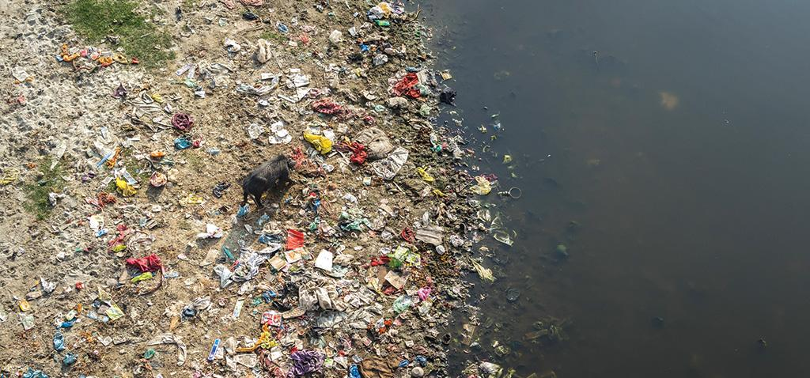

(Figure 6)

This substantial contamination of the stream causes numerous issues for the individuals around it. As indicated by the WHO, or the World Health Organization, about 5% of the passings in India in 2004 were brought about by waterborne illnesses. The natural contamination is hazardous and can prompt various diseases. Nonetheless, a framework is needed for averting a more considerable amount of pollution. In this framework, the sewage would be gone through a progression of lakes before streaming into the river. Daylight, microalgae, microscopic organisms, and gravity would sterilize the water. This would lessen the measure of crude sewage siphoned into a stream, and hence make the water more safe.

**4.3 Death rituals performed in the Ganges**

Numerous pieces of the Hindu beliefs spin around the Ganges River, who they accept is the Mother Ganga on Earth. Recognizing that she will clean their souls, many would like to be put in her waters in the wake of passing on to endeavour to bring their souls up and at last reach Moksha. Along these lines, numerous individuals' bodies and cinders are put in the river. A lot of cinders from crematoriums along the Ganges River in Varanasi are dumped every year. A more significant part of Hindus is incinerated and put in the stream in the wake of being scorched by Dalits along the ghats driving into their goddess' body. These cinders are shielding the river from being perfect, and a significant number of the individuals who drink the water are likewise fundamentally ingesting dead individuals, which is a disturbing idea. This demonstrates how the crematoriums need to locate another spot to dump the cinders, possibly downstream, so it is more secure for the individuals who drink and wash in the water.

Dead bodies are likewise colossal contamination to the effectively dirty water. Thirty-five thousand bodies are evaluated to be disposed of into the stream yearly. This is an appalling measure of dead individuals to skim around in a significant wellspring of water for a vast number of individuals around it.

**4.4 Urbanization**

Rapid urbanization in India during the ongoing decades has offered to ascend to various natural issues, for example, water supply, wastewater, and its assortment, treatment, and transfer. Numerous towns and urban areas which came upon the banks of rivers have not given a legitimate idea to issue of wastewater, sewerage, and so forth. In urban territories, water is tapped for local and modern use from rivers, streams, lakes, lakes, wells, and so on. About 80% of the water provided for household use drops as wastewater. Much of the time, this wastewater is let out untreated and causes massive scale contamination of the surface water. A piece of it permeates into the ground and sullies the groundwater. Class I urban communities produce as much as 16,662 Million liters of wastewater. About 70% of the number of inhabitants in class I urban communities is furnished with sewerage office. The Ganga stream bowl contributes around 33% of the complete wastewater of India.

According to the most recent gauge out of 23 thousand MId of wastewater created, just 6,000 Mid i.e. roughly 26%, is treated before letting out; the rest is arranged off untreated. The degree of treatment accessible in urban areas with an existing treatment plant differs from 2.5% to 89% of the sewage produced. Treated or incompletely treated or untreated wastewater is arranged into common channels joining rivers or lakes or utilized ashore for water system/grain development or to the ocean or a mix of them by the districts.

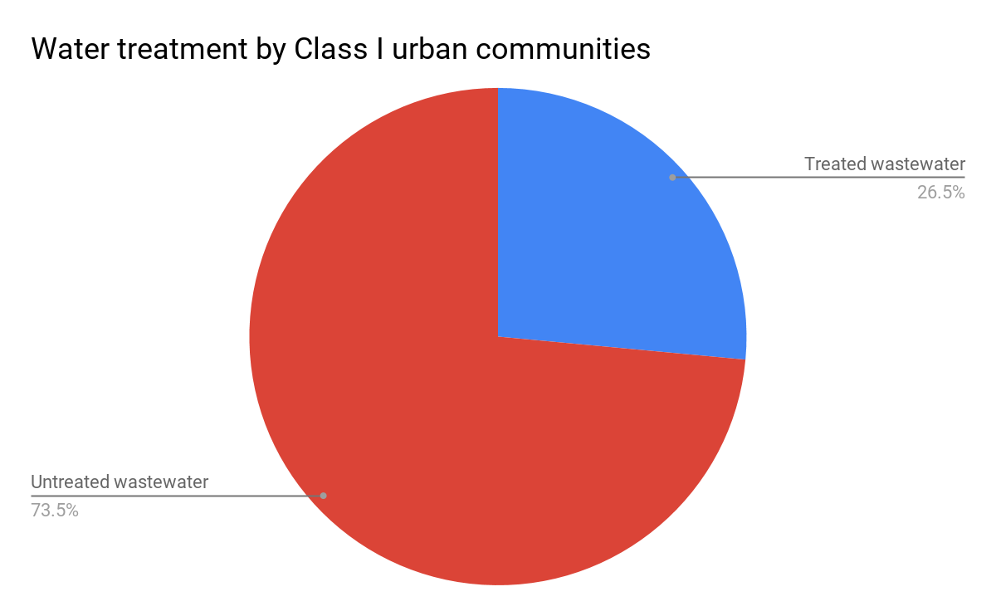

(Figure 7)

Municipal water treatment offices in India, at present, don't evacuate hints of substantial metals. Given the way that vigorously dirtied streams are significant wellsprings of city water for most towns and urban communities along with their courses, it is accepted that each purchaser has been, throughout the years, presented to undisclosed amounts of poisons in the water they have devoured. To add to this, Indian towns and urban communities have developed spontaneously because of quick populace development. Offices for running water have been given in numerous towns and even in certain cities during the last couple of decades. This has brought about the utilization of flush-lavatories and a lot bigger utilization of water in the home for washing, washing of garments, utensils, and so forth., creating vast amounts of wastewater.

As per criteria set by the Central Pollution Control Board (CPCB), just 22% of the wastewater from class I urban communities and 14% from class II urban areas is being gathered through sewerage. Countless urban areas/towns either don't have any sewerage framework or the sewerage framework is over-burden or old — this outcome in a tremendous amount of wastewater uncollected.

As per a data by CPCB, just around 40-half of the number of inhabitants in the significant metropolitan areas like Delhi, Mumbai, Kolkata, Chennai, and Bangalore are served by sewers frameworks. Indeed, even where their sewers exist, they regularly release or flood, discharging their substance to storm-water or other surface depletes or permeates into the dirt to arrive at groundwater. Regularly uncollected and untreated sewage water enters the streams in this way, contaminating their water.

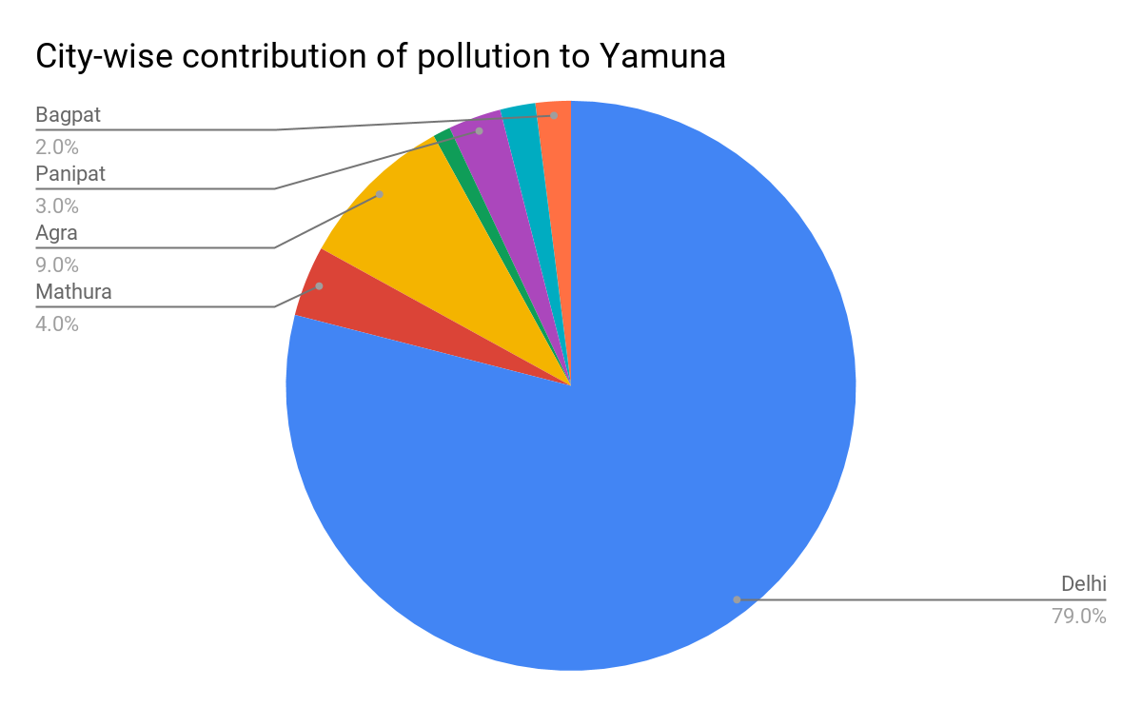

(Figure 8)

**4.5 Agricultural practices in Yamuna**

Composts and pesticides are squandered into the closest water-bodies at the beginning of the storms, or at whatever point, there are substantial showers. As the purpose of a section of such horticultural data sources is diffused all through the river bowl, they are named as non-point wellsprings of contamination. Although the water system has expanded extensively in the nation, minimal valuable has been done to handle the issue of the high saltiness return water. This is the circumstance in Punjab and Haryana. In Haryana, the 40 km long channel pours 250,000 kg/day of chlorides into the Yamuna to bring the chloride fixation up in the stream from 32 mg for every litre only upstream of the channel conversion to 150 mg for each litre only downstream of it. Also, the vast majority of these chlorides are from farming return streams.

As per the discoveries of the CPCB, a portion of the drainage into the channel contains more than 15,000 mg for every liter of chlorides. Concentrated and regularly expanding the utilization of compound composts, pesticides, weedicides, and different synthetic substances is adding another measurement to such contamination. Researchers with the Indian Agricultural Research Institute (IARI), New Delhi, ranchers regularly enjoy abundance utilization of composts and pesticides. When these are utilized more than the prescribed portions, they contaminate water, land, and air. Flood-plain development is another huge supporter of water contamination. Composts and pesticides utilized in these tracts of land will undoubtedly be washed into rivers during the storms.

**4.6 Religious beliefs**

Religious beliefs and social practices likewise add to the contamination of our stream waters. Remains of dairy cattle and different creatures are arranged in the streams. Dead bodies are incinerated on the stream banks. Mostly consumed bodies are additionally flung into the stream. This is done as an issue of strict confidence and concerning antiquated ceremonies. These practices contaminate the stream water and antagonistically influence water quality.

Mass washing in a stream during strict celebrations is another destructive earth practice. Studies have uncovered that the biochemical oxygen request (BOD) goes up radically. Strict practices likewise request that contributions from a puja to be performed in a river. It is likely to see individuals flooding gifts in plastic sacks. Plastic packs are extremely risky, and further adds to the contamination heap of the river.

## **4.7 Sabarmati Pollution**

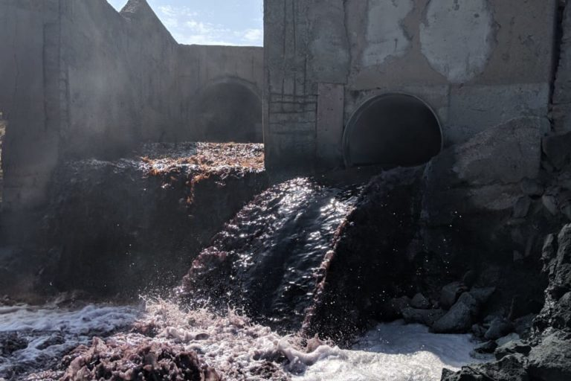

(Figure 9)

A cumulative investigation carried by the Gujarat Pollution Control Board (GPCB) and the Paryavaran Suraksha Samiti (PSS) on the Sabarmati river, had revealed that 120 km of the river before it touches the Arabian sea, is ridden with industrial and agriculture waste including chemicals, fertilizers, and sewage. The shocking effect of all these irresponsibilities and pollution has lead to a point, that the Sabarmati river has no longer any freshwaters remains as it enters the city of Ahmedabad. The riverfront of the Sabarmati river has merely become a pool of polluted stagnant water. The impact of the high levels of Pollution in the Sabarmati river’s water on the people and surrounding environment includes, “contamination of groundwater, contamination of food(especially the foods which are grown near the riverfront of Sabarmati) ”. Associated Health_hazards and the loss of flora and fauna.

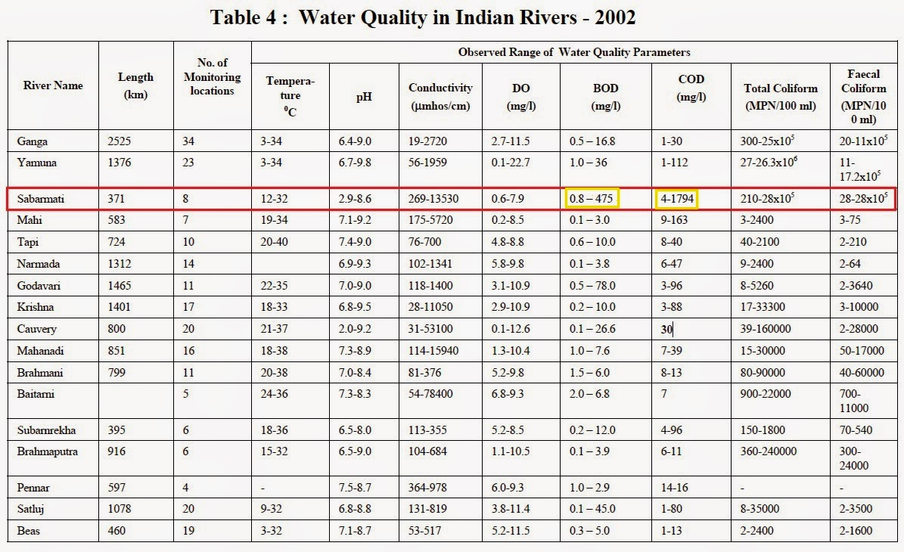

(Table 3)

# **5. EFFECTS OF WATER POLLUTION**

Under the data provided by the World Health Organisation (WHO), water pollution is responsible for about 4 percent of deaths in humans in the world. Water pollution is responsible for 4.7 percent of all disabilities and health issues in the world. More than 50% of humanity has to suffer diseases due to water pollution at least once in their life. Water is necessary for human life, so due to a lack of choices, many people have to drink polluted water, which affects them severely.

Pollution due to pesticides is very harmful to human health. The below figure shows the percentage use of different pesticides in the world and India. The main pesticide that is used in India are insecticides which account for 76% of pesticides used in India.

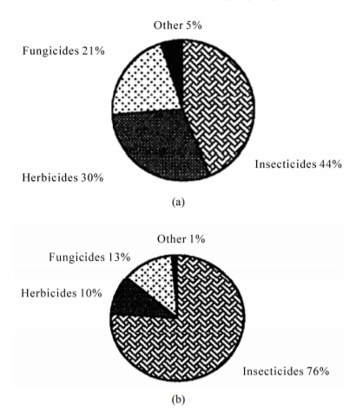

(Figure 10)

**(a-Composition of pesticides in the World b-Composition of Pesticides in India)**

**(Source-H. N. Saiyed, V. K. Bhatnagar and R. Kashyap,1999-2003. )**

Farmers use pesticides mainly with cotton, wheat, and paddy crops. About 99% of pesticides used on farmlands remain unutilized. These pesticides are carried away by air and water or absorbed by the soil. This causes disease for aquatic animals where the pesticides are carried away by rainwater and runoffs. The following table shows the toxicity of famous pesticides.

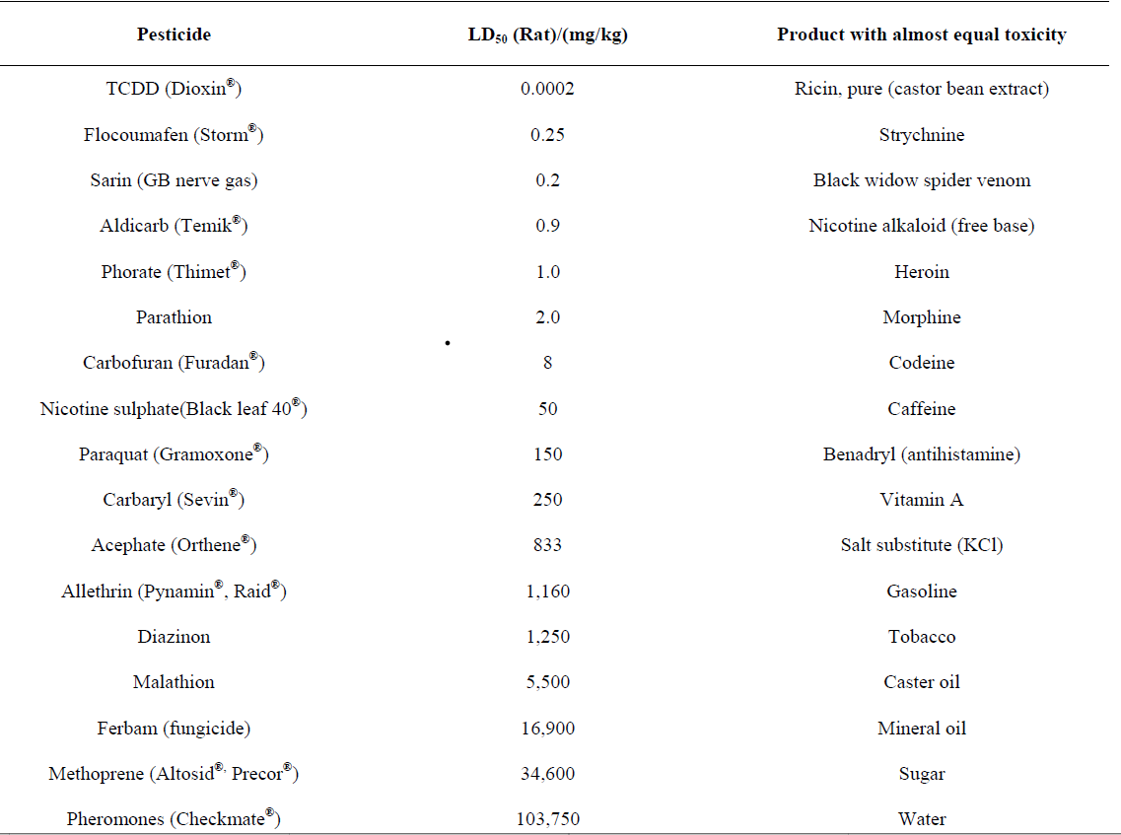

(Table 4)

It would be shocking to see that toxicity of some of these pesticides is comparable to ricin, morphine, Heroin, and Black Widow spider venom. LD50 is a measure of a substance’s toxicity. LD50 for a particular animal is the amount of that substance in the body enough to kill half of that population. Many of these pesticides persist in the environment for long periods losing just a negligible part of their toxicity. These harmful pesticides enter aquatic bodies through leaching and surface runoffs.

Nitrogen-based fertilizers and nitrogen from animal release on farmland are first transformed into ammonium and then into nitrates and then into nitrites. *Methemoglobinemia* is a condition developed in infants when their digestive system converts nitrates into nitrites. These nitrites reduce the ability of the blood to carry oxygen. Nitrites are also carcinogenic and cause cancer. Fertilizers that are rich in phosphorus and nitrogen lead to algae growth in ponds. These algae consume a lot of dissolved oxygen, leaving less oxygen for other aquatic organisms. This leads to the rapid aging of the ponds and the death of many marine species. Suspended sediments from industrial discharge like fly ash and particulate matter cause less sunlight to enter the ponds directly affecting aquatic plants. Prolonged exposure to a high concentration of nitrates in drinking water leads to many problems like cancer and issues in the reproductive system. This contaminated water enters into a human being after eating fish living in contaminated water or by drinking contaminated water.

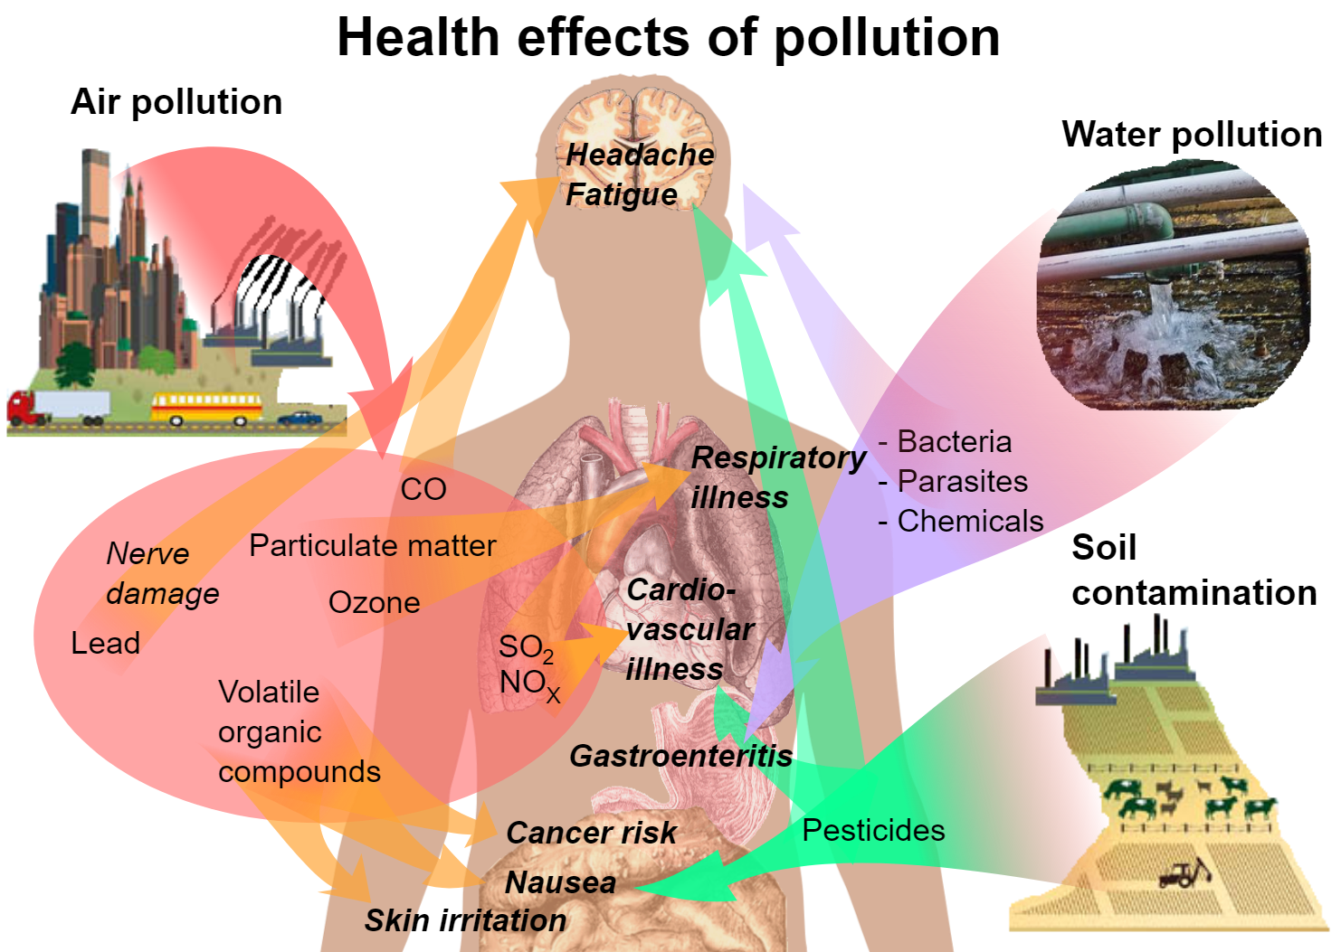

(Figure 11)

(**Source-**[**https://fr.wikipedia.org/wiki/Fichier:Health_effects_of_pollution.svg**](https://fr.wikipedia.org/wiki/Fichier:Health_effects_of_pollution.svg)**)**

The industrial discharge also adds a lot of dangerous chemicals to the water bodies like nitrates, arsenic, and fluorides. Fluorides cause teeth to become brittle and damages the spinal cord. Arsenic damages the kidneys, liver, and lungs. Lead that is released from pesticides as well as industrial discharge damages the central nervous system. Oil spills release petrochemicals into the cancerous water bodies. Water polluted with fecal matter, dead bodies and sewage are the perfect environments for microorganisms like bacteria, viruses, worms, protozoa, and algae to thrive. These microorganisms, when consumed by humans, cause many deadly waterborne diseases. Cholera, which is a painful and fatal disease, is a waterborne caused by the bacteria Vibrio Cholerae. Diarrhoea is also a waterborne disease caused by the bacteria E. Coli. Diarrhoea, if left untreated, can cause death by draining the body of fluids. Many other diseases like Botulism, dysentery, Hepatitis A, Polio, SARS, and typhoid are caused by drinking contaminated water.

# 

# **6. METHODS TO REDUCE POLLUTION**

Water pollution has gone up so much over the past years that if it is not stopped, it will become hazardous and our river will become practically dead. After learning about what are the reasons for pollution in these rivers in the section above, our next aim is to find an effective solution that can minimize the harmful chemicals and unwanted substances in the streams. Water pollution is a problem in every country that has gone through an industrial revolution, and there are a number of countries that have been able to clean their river. One of them is the United Kingdom (Thames River), and the other is China. Taking a closer look at what caused water pollution in those countries and what measures were taken by them to clean their water bodies.

**6.1 Thames River**

The Thames ran through the centre of London. After the industrial revolution, water pollution became so severe that the river was declared biologically dead by the scientists. In 1878 many passengers were killed when a steamship Princess Alice sank, and the poisonous water of the river overcame people when trying to get to the shore. The oxygen level in the river became so low that there were only two species of fish left at that time. Through research, it was found that the primary causes of pollution were the waste from the factories or industries and from the sewage which were dropping directly into the river without cleaning. This situation is quite close to that of the rivers in India. Many efforts were taken to clean up the river, industries were asked not to dump their waste into the river, and the sewage was treated before dumping. People were made aware of the harmful effects of pesticides and fertilizers, which were washed into the river. The population took several efforts themselves, and the Thames has become a lot better than before and now has more than 20 species living in it. Through this, we can say that it is possible for Indians as well.

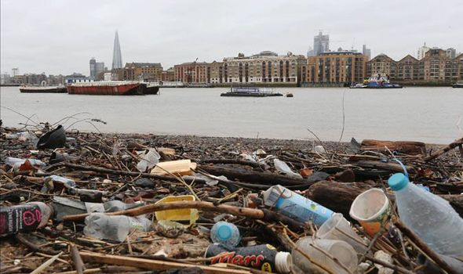 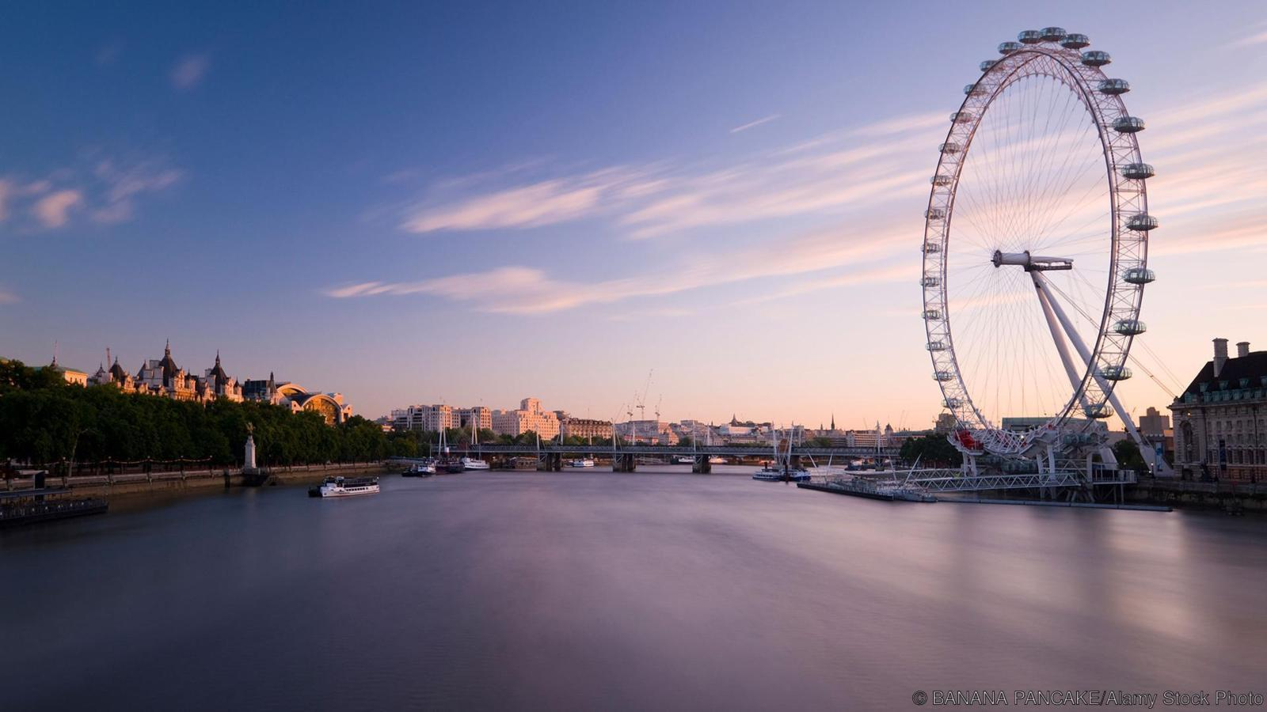

**(**Figure 12**)**

**6.2 Pollution control in China**

Now, if we look at China, it also had a similar situation just like that of the UK and current India due to industrial waste as well as sewage waste being poured into the rivers. Under the Institute of Public and Environmental Affairs, only 32 percent of the water was suitable in China. The Chinese government took the issue seriously and made laws to control the situation. The government set objective, which was for a five-year target. In 2014, 300 million US dollars were spent by the government to solve water pollution along with three deadlines set for the years 2015, 2020, and 2030. These deadlines were placed to decrease the pollution in the rivers by strict rules along with their enforcement, regular monitoring, and punish anyone who tries to violate these rules.

.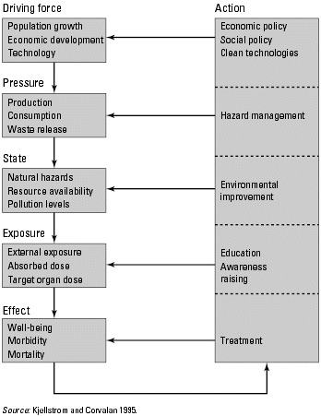

(Figure 13)

India is in a situation where it requires to act fast if we want to solve water pollution. We can learn and apply the solutions mentioned above, opted by the UK and China. The figure2 above gives us an idea of what could be done to stop water pollution. It is on us to decide whether we want to remove the harmful particles, reduce them, or penalize the industries or the people for throwing them into the rivers. In 1993, the United Nations Industrial Development Organization started the Demonstration in Small Industries for Reducing Wastes Project in India to check the effect of pollution reduction on the industries' production. With the help of the experts, more than 500 options were identified for around 12 companies. It was found that the companies invested approximately 300 thousand USD on the implantation of the pollution control techniques and saved 3 million USD on raw material, water, and waste treatment cost. This project demonstrated that with the pollution control method, industries could even make a decent profit.

**6.3 Steps that can be taken**

Now let's look into the various steps that we can take to control water pollution in Indian rivers. The most integral step is to stop the direct flow of industrial waste and sewage into the rivers. Industrial waste which doesn't contain any toxic chemical should be treated and then dumped after proper inspection, similarly for sewage waste. Any chemical container should be recycled and reused to stop the leaching of toxic chemicals into the river. Various techniques are available which can filter the toxic waste. Some of them are adding chemicals that make the poisonous settle down or changing the pH value of the polluted water. If we look at Delhi sewage treatment plants, they are running at their maximum rate, so there is a requirement to set up new treatment plants with the best available technologies. We need to shift the encroachments near the flood plain areas near Ganga or any other river, and a strict ban should be made on any construction within a certain distance of the rivers. Strict rules have to be made to stop people from washing their clothes in the rivers. Separate places can be built where people can do their domestic chores that involve river water like washing clothes, and this water can be recycled and reused after treatment. There should be a check on the dumping of solid wastes into the river. We can also support various NGOs who are working on different alternative solutions.

For example, flowers and various organic religious products dumped into Ganga by people are collected from the temples, gurudwara, and converted into an incense stick and scents by HELP US GREEN.

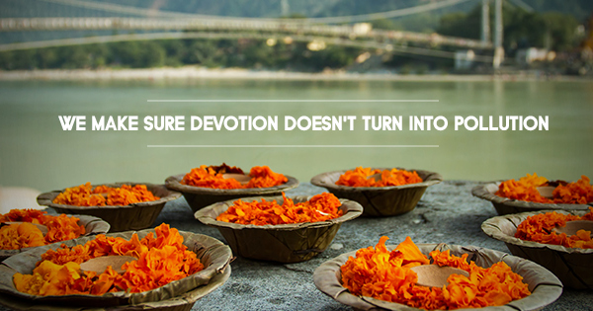**HELP US GREEN**

(Figure 14)

Another company made a robot that collects all the floating waste from the surface of the water, which can be thrown elsewhere. Omnipresent Robot Tech Pvt Ltd creates this robot. It is all time working robot in all-weather conditions. These robots, in large quantities, can remove waste. Also, there is a necessity to spread awareness among the public about the need to keep the rivers clean. If people start to follow the rivers clean, then water pollution will itself begin to lower down.

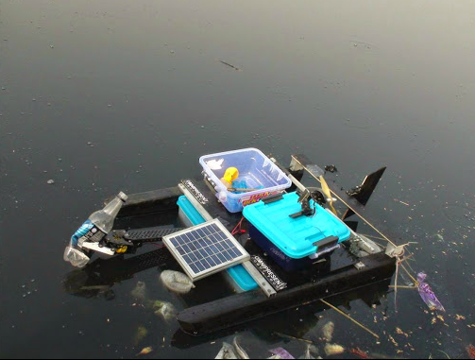

(Figure 15)

**6.4 Ganga Action Plan (GAP)**

The Ganga action plan was propelled by Shri Rajeev Gandhi with the fundamental target of making Ganga pollution-free. Different targets of the Ganga Action Plan are as follows:

* Innovative work to monitor the biotic, assorted variety of the river to expand its productivity.
* Control of non-point contamination from horticultural runoff, human poo, steers floundering and tossing of unburnt and half-consumed bodies into the waterway.
* Asset recuperation alternatives like the creation of methane for vitality age and utilization of aquaculture for income age have been illustrated.
* An innovation of sewage treatment like Up-stream Anaerobic Sludge Blanket (UASB) and sewage treatment through afforestation has been expertly created.
* Recovery of delicate shelled turtles for contamination decrease of the stream has been shown and discovered to be helpful.
* To go about as trailblazer for making up comparative move designs in other contaminated stretches in different rivers.

|  |  |  |  |  |
| --- | --- | --- | --- | --- |
| **PARAMETERS** | **THAMES** | **RHINE** | **DANUBE** | **GANGA** |
| Length (in Km) | 245 | 1320 | 2857 | 2525 |
| Population (in millions) | - | 50 | 86 | 500 |
| Restoration Time (in years) | 30 | 50 | 13+ | 13+ |
| Restoration Cost (in Billion rupees) | 5.0 | 1940.0 | 125.0 | 11.2 |

(table 5 )

# **7. RESULT**

This paper establishes that water pollution is hazardous to human health, and measures should be taken to reduce this pollution. Industrialization, Urbanization, Religious practices, etc. have all contributed towards the contamination of these rivers. Some astonishing insights we found from the research are as follows -

* Some parts of the Sabarmati have a pH range close to 2.9, making it very acidic and deadly for consumption.
* 2,900,000,000 litres of wastewater are siphoned into the Ganges river every day. Out of which, only 31% of the water gets treated.
* The engineering industry is contributing to water pollution more than any other sector in India.
* Waterborne diseases contribute to 5% of deaths in India.
* A fisherman fishing in the Ganga caught a dead body of a child in his angler
* Urban households contribute the maximum in contamination of water. These include a lot of metropolitan cities.
* Delhi contributes to 79% of the pollution in the Yamuna
* Unlike India, the US has spent a mammoth 300 million dollars to cure its water bodies
* HELP US GREEN organization contributes a lot towards saving Ganga
* Methemoglobinemia is developed in infants
* Industrial discharges affect the human body in various places, including teeth, spinal cord, kidneys, liver, lungs, etc.
* Polluted water becomes an ideal place for microorganisms like bacteria, viruses, worms, protozoa, and algae to thrive and be the reason for diseases in humans
* Drinking this contaminated water is responsible for many diseases in humans.
* More than 50% of humanity has to suffer from diseases due to water pollution at least once in their life.

Based on our findings, it is safe for us to say that the time has come to take appropriate measures to stop the pollution of rivers.

# **8. DISCUSSION**

So, we have discussed the pollution thoroughly. How water pollution originated, what are its effects on life forms on earth, and most importantly, what can be done to reduce it or completely eradicate it? But all these are not enough.

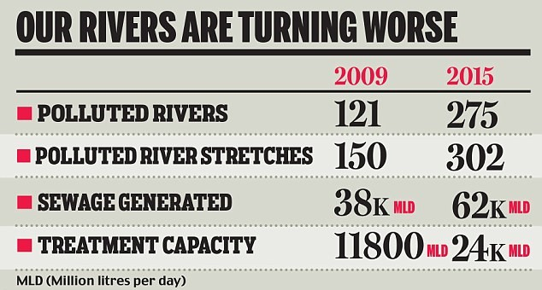

(Table 6)

We have said this a million times, and we have to shout it million times again that the leading cause of degradation of the resources of mother earth are its children - Humans. Humans have done everything they can do to attain their motive of going forward in life, but fools do not realize the cost of it. We know man originates all the forms of pollution but what we are doing to stop it - nothing. The water, which is an elixir, is converted into poison by the humans. So, the crux of the matter is quite simple; all these reforms, these rules, and regulations are worthless if we - humans don’t make a change. We have to change our thinking. We have to treat the water as it is - an elixir. Only then we will be able to protect its pure form. There must be some drives which should make people aware of their contribution to pollution, and they should feel guilt. The one caught while polluting water sources in any kind should be looked down upon and should be punished. We are not saying that the punishment should be severe, but they should be left alone. The society needs to change. Only then we can hope of finding any reliable solution for this menace.

References

[1] Pal, S. (2017, January 12). How Three Startups Are Using Innovative Methods to Clean and Restore River Ganga. Retrieved from <https://www.thebetterindia.com/81881/clean-ganga-innovative-technology-startup/>.

[2] Hardach, S. (2015, November 12). Earth - How the River Thames was brought back from the dead. Retrieved from <http://www.bbc.com/earth/story/20151111-how-the-river-thames-was-brought-back-from-the-dead>.

[3] Kjellstrom, T. (1970, January 1). Figure 43.1, [Framework for Environmental Health Interventions]. - Disease Control Priorities in Developing Countries - NCBI Bookshelf. Retrieved from <https://www.ncbi.nlm.nih.gov/books/NBK11769/figure/A6253/?report=objectonly>

[4] Kjellstrom, T. (1970, January 1). Box 43.4, Water Pollution Control in India - Disease Control Priorities in Developing Countries - NCBI Bookshelf. Retrieved from <https://www.ncbi.nlm.nih.gov/books/NBK11769/box/A6257/?report=objectonly>

[5] Pal, S. (2017, January 12). How Three Startups Are Using Innovative Methods to Clean and Restore River Ganga. Retrieved from <https://www.thebetterindia.com/81881/clean-ganga-innovative-technology-startup/>.

[6] Gray, R. (2010, October 13). The clean up of the River Thames. Retrieved from <https://www.telegraph.co.uk/news/earth/wildlife/8059970/The-clean-up-of-the-River-Thames.html>.

[7] Tackling China's water pollution. (2017, October 1). Retrieved from <https://www.policyforum.net/tackling-chinas-water-pollution/>

[8] Cartwright, M. (2019, November 30). Ganges. Retrieved from

<https://www.ancient.eu/Ganges/>

[9] Ahmad, N., & Lodrick, D. O. (2019, November 1). Ganges River. Retrieved from <https://www.britannica.com/place/Ganges-River>.

[10] Ganges River Pollution. (n.d.). Retrieved from

<https://gangapollution.weebly.com/>.

[11] 5 Major Causes of Water Pollution in India. (2013, December 18). Retrieved from <http://www.yourarticlelibrary.com/water-pollution/5-major-causes-of-water-pollution-in-india/19764>.

[12] Systems, K. R. (2019, November 6). The Most Polluted Rivers of... Retrieved from <https://www.kent.co.in/blog/the-most-polluted-rivers-of-india/>.

[13] Onkar. (1970, January 1). Pollution in Sabarmati River: What is the truth? Retrieved from <http://onkarpandey.blogspot.com/2014/05/pollution-in-sabarmati-river-what-is.html>

[14] Aditya Dev | TNN | Updated: Sep 27, 2016. (n.d.). Central Pollution Control Board: 63% of sewage flows into rivers untreated every day: Central Pollution Control Board: Agra News - Times of India. Retrieved from <https://timesofindia.indiatimes.com/city/agra/63-of-sewage-flows-into-rivers-untreated-every-day-Central-Pollution-Control-Board/articleshow/54531095.cms>

[15] Narayanan, C. (2009, November 16). River of disease. Retrieved from <https://www.livemint.com/Leisure/7aju1DGoRcJpeviMgoZBmJ/River-of-disease.html>.

[16] Unsafe drinking-water, sanitation and waste management. (2016, August 4). Retrieved from <https://www.who.int/sustainable-development/cities/health-risks/water-sanitation/en/>.

[17] How Does Water Pollution Affect Humans? (n.d.). Retrieved from <https://www.theworldcounts.com/stories/how-does-water-pollution-affect-humans>.

[18] Waterborne diseases. (2019, November 13). Retrieved from <https://en.wikipedia.org/wiki/Waterborne_diseases>.

[19] Sabarmati, the river that Gandhi once chose to live by, is now dry and polluted. (2019, April 9). Retrieved from <https://india.mongabay.com/2019/04/sabarmati-the-river-that-gandhi-once-chose-to-live-by-is-now-dry-and-polluted/>

1.